Review
Article Title

Article Title (Spanish)

First and last name,¹ First and last name,² First and last name joined by a hyphen…^{3*}

¹ Write each author's complete institutional affiliation, including the area, unit or department, the institution, city, and country. Do not use acronyms or abbreviations. ORCID: XXXX-XXXX-XXXX-XXXX
² Write each author's complete institutional affiliation, including the area, unit or department, the institution, city, and country. Do not use acronyms or abbreviations. ORCID: XXXX-XXXX-XXXX-XXXX
³ Write each author's complete institutional affiliation, including the area, unit or department, the institution, city, and country. Do not use acronyms or abbreviations. ORCID: XXXX-XXXX-XXXX-XXXX

*Corresponding author: First and last name. Email: xxxxxxxxxx

General Instructions

Before preparing your manuscript, please read this guide carefully.

Contributions must be submitted in Word format (.docx) using this template, which defines the font (Garamond), font size, margins, and line spacing. Manuscripts submitted in PDF or any format other than those specified will not be accepted.

Compliance with this template is a technical requirement for initiating the editorial process. Manuscripts that do not conform to these guidelines may be returned to the authors before editorial evaluation.

The use of international reporting guidelines appropriate to the study design is recommended, as they help improve the structure, transparency, and quality of the manuscript. Among the most widely used are:

- STROBE – observational studies
- CONSORT – randomized clinical trials
- PRISMA – systematic reviews and meta-analyses
- MOOSE – meta-analyses of observational studies
- SRQR / COREQ – qualitative studies

It is suggested that the corresponding checklist be attached as supplementary material. To consult these guidelines, visit: https://www.equator-network.org

All authors must review and approve the final version of the manuscript prior to submission. Manuscripts containing spelling, grammatical, or structural errors may be returned during the initial editorial review, before being sent for peer review.

Once you have read and understood these guidelines, please delete this section before completing the template.

Abstract
The suggested length for this section is up to 250 words.
Objective: briefly describe the purpose of the review and the thematic approach adopted. Methods: indicate the databases consulted, the inclusion/exclusion criteria, the approximate number of studies considered, and the source selection procedure. Content synthesis: indicate the main axes of the analysis, the thematic categories, or the structured lines of discussion. Conclusion: summarize the critical contribution of the review and its relevance to the academic or clinical field.

Suggested citation: For journal use only.
Received: XXXXXX
Revised: XXXXXX
Accepted: XXXXXX

This is an Open Access article under the CC BY-NC-ND license (https://creativecommons.org/licenses/by-nc-nd/4.0).
Keywords: include three to six keywords, separated by semicolons; all keywords begin with a capital letter (except acronyms) and must be validated in the MeSH thesaurus (Medical Subject Headings), available at: https://www.ncbi.nlm.nih.gov/mesh

Abstract (Spanish)

The Spanish abstract must contain the same information as the English abstract.

Keywords (Spanish): provide the keywords in Spanish, separated by commas and written in lowercase, except for proper nouns or acronyms. All must be validated in the MeSH thesaurus (Medical Subject Headings), available at: https://www.ncbi.nlm.nih.gov/mesh

Body of the text
The article must begin with an introduction in which the central problem is presented, the need for the review is justified, and its scope is delimited. It is essential to explicitly state the objective, as well as the general criteria for source selection as methods: indicate the databases consulted, the inclusion/exclusion criteria, the approximate number of studies considered, and the source selection procedure. Generic introductions or texts without a clear thematic delimitation will not be accepted.
The development of the text should be organized using thematic headings relevant to the object of analysis, such as conceptual categories, clinical dimensions, historical trajectories, or lines of debate. A critical synthesis of the available knowledge is expected, one that contrasts sources, identifies gaps or contradictions, and provides well-supported arguments. Citations must be integrated into the discussion, not placed as loose or decorative references.
In the case of reviews with a clinical focus, a more systematic structure may be adopted that includes, as appropriate, the following components: relevant definitions, pathophysiology, risk factors, clinical presentation, diagnosis, treatment, and conclusions. This organization is useful when addressing diseases, syndromes, or medical interventions from a comprehensive, evidence-based perspective.
Graphic resources
The use of graphic resources is optional and must be fully justified. They should only be included if they facilitate understanding of the content or allow complex information to be synthesized that cannot be expressed with the same clarity in the text. They do not replace the written analysis and must not repeat information already developed in the body of the article.
They must meet the following criteria:
• They must not duplicate information already presented in the text or in the figures.
• They must be numbered according to their order of appearance in the manuscript.
• The title must be self-explanatory, allowing the reader to understand its content without depending on the body of the text.
Important note.
The use of previously published images, tables, or graphs is not permitted. All graphic resources must be original and unpublished, created specifically for the manuscript. A maximum of five graphic resources in total is allowed (tables, figures, or graphs). Tables must be editable, while figures and graphs must have a minimum resolution of 300 DPI and dimensions no smaller than 20 × 20 cm. All must include a title and, where applicable, a figure or table caption; examples are attached below.

Figure 1. Risk assessment matrix. Must be placed after its first mention in the text.
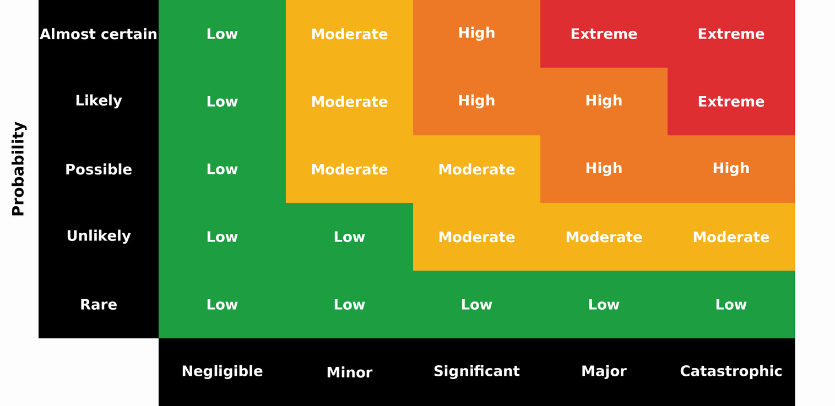
The figure shows the relationship between the probability of occurrence and the severity of impact. Risk levels are classified as low (green), moderate (yellow), high (orange), and extreme (red), according to the combination of both factors.

Table 1. Representative example of a table. Must be placed after its first mention in the text.
Title 1 | Title 2 | Title 3* | Title 4*
Name | Value | Value | Value
Name | Value | Value | Value
Name | Value | Value | Value
Name | Value | Value | Value
Name | Value | Value | Value
Name | Value | Value | Value
Name | Value | Value | Value
Name | Value | Value | Value
Name | Value | Value | Value
Name | Value | Value | Value
Name | Value | Value | Value
*Clarifications on relevant aspects of the information presented may be included.

Table 2. Representative example of a table. Authors may modify the table type. Must be placed after its first mention in the text.
Title 1 | Title 2 | Title 3*
Name | Value | Value
Name | Value | Value
Name | Value | Value
Name | Value | Value
Name | Value | Value
*Clarifications on relevant aspects of the information presented may be included.

Figure X. Altered clinical parameters in COVID-19 patients treated in Internal Medicine (n = 150). Must be placed after its first mention in the text.
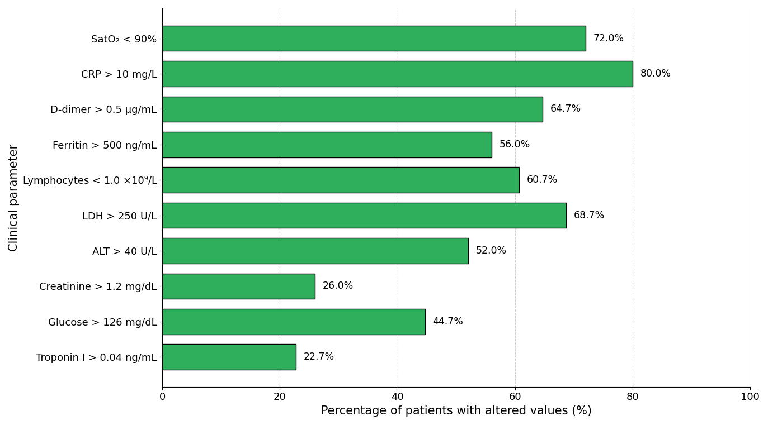

Every narrative review must conclude with a final closing section, in which the manuscript's main contribution and its usefulness in the clinical, academic, or institutional setting are clearly presented. This conclusion should not be a repetition of the abstract or an unsupported generalization, but rather a well-argued synthesis of the central findings and proposals.

Supplementary material (if applicable)
If there is supplementary material, please indicate what it consists of (e.g., tables, instruments, graphs).

Acknowledgments (if applicable)
Include this section only if applicable. It may be used to acknowledge the collaboration of individuals, institutions, or groups that contributed to the study without meeting authorship criteria.

Data Availability Statement
All manuscripts published in the Revista Especialidad Médica must include a data availability statement. In this section, authors must indicate where the data supporting the reported results can be accessed, including, where applicable, the link to the public repository in which the datasets generated or analyzed during the study are deposited.

Examples:
Data available upon request: The data supporting the results of this study are available upon reasonable request to the corresponding author, subject to applicable ethical and confidentiality considerations.
Data available in repository: The data supporting the results of this study are available in [repository name], at [link or identifier].
Not applicable: Data availability is not applicable to this manuscript, as no datasets were generated or analyzed.

AI Use Statement (if applicable)

If generative artificial intelligence tools were used to support literature synthesis, style review, or any other phase of manuscript preparation, briefly disclose this, specifying the tool used and its purpose. The authors assume full responsibility for the final content. Example:

[Tool name] was used as a support tool for literature synthesis and style review. The author assumes full responsibility for the content.

Author contributions
Briefly and precisely indicate each author's role in preparing the manuscript, in accordance with the international CRediT (Contributor Roles Taxonomy) taxonomy. Each author must be explicitly linked to one or more contributions and must have reviewed and approved the final version of the text. Submission of the manuscript implies acceptance of individual responsibility for the declared contributions.
Example:
XX XX: conceptualization, methodology, writing – original draft;
XX XX: data curation, formal analysis, validation;
XX X: interpretation, supervision, writing – review and editing.
The roles recognized by the CRediT taxonomy include: conceptualization, data curation, formal analysis, funding acquisition, investigation, methodology, project administration, resources, software, supervision, validation, visualization, writing – original draft, and writing – review and editing.

Funding
Indicate the funding sources that supported the study, including institutional projects, public funds, international agencies, non-governmental organizations, or private sponsorship, if applicable.
If no external funding was received, write the following:
This research received no external funding.

Conflicts of interest
Indicate any potential conflicts of interest; if none apply, please state the following:
The authors declare no conflicts of interest.

References (minimum 30; maximum 60)
The purpose of this section is to present a list of up-to-date, relevant, and international sources that scientifically support the content of the manuscript. This is one of the sections with the highest number of errors, so it is recommended to carefully check the accuracy of each reference.

All citations must follow Vancouver style with superscript and be verified before submitting the manuscript, regardless of the reference manager used. DOIs must be functional.

Example for journal articles
Rouleau K, Bourget M, Chege P, Couturier F, Godoy-Ruiz P, Grand’Maison P, et al. Strengthening Primary Care Through Family Medicine Around the World: Collaborating Toward Promising Practices. Fam Med. 2018;50(6):426-436. DOI: 10.22454/FamMed.2018.210965.

Example for web pages
World Health Organization. Life expectancy at birth 2000–2015 [Internet]. [cited 2016 Nov 22]. Available from: https://gamapserver.who.int/gho/interactive_charts/mbd/life_expectancy/atlas.html

Example for complete book
Bell J. Doing your research project. 5th ed. Maidenhead: Open University Press; 2005.

Example for book chapter
Franklin AW. Management of the problem. In: Smith SM, editor. The maltreatment of children. Lancaster: MTP; 2002. p. 83-95.

