Case Report
Article Title

Article Title (Spanish)

First name(s) Last name-Last name,¹ First name(s) Last name-Last name,² First name(s) Last name-Last name³*…

¹ Write the author’s complete institutional affiliation, including the area, unit or department, institution, city, and country. Do not use acronyms or abbreviations. ORCID: XXXX-XXXX-XXXX-XXXX. Email: xxxxxxxxxx
² Write the author’s complete institutional affiliation, including the area, unit or department, institution, city, and country. Do not use acronyms or abbreviations. ORCID: XXXX-XXXX-XXXX-XXXX. Email: xxxxxxxxxx
³ Write the author’s complete institutional affiliation, including the area, unit or department, institution, city, and country. Do not use acronyms or abbreviations. ORCID: XXXX-XXXX-XXXX-XXXX. Email: xxxxxxxxxx

*Corresponding author: First name(s) Last name-Last name. Email: xxxxxxxxxx

General Instructions

Before preparing your manuscript, please read this guide carefully.

Contributions must be submitted in Word format (.docx) using this template, which defines the font (Garamond), font size, margins, and line spacing. Manuscripts submitted in PDF or any format other than those specified will not be accepted.

Compliance with this template is a technical requirement for initiating the editorial process. Manuscripts that do not conform to these guidelines may be returned to the authors before editorial evaluation.

This section publishes unique or particularly noteworthy clinical cases that provide relevant elements for diagnosis, treatment, prevention, follow-up, or clinical learning. Manuscripts must clearly and systematically document relevant clinical situations, such as unusual diagnoses, atypical treatment responses, significant adverse effects, diagnostic errors with educational value, or clinical dilemmas with ethical or therapeutic implications. Manuscripts must provide substantive clinical, ethical, or epidemiological learning. Anecdotal descriptions or common conditions without critical analysis or educational value are not accepted.

It is recommended to follow the international CARE guideline for presenting case reports and to attach the corresponding checklist as supplementary material. Available at: https://www.care-statement.org

All manuscripts must comply with current ethical requirements:
- Written informed consent, signed by the patient or their legal representative.
- Approval by an ethics committee, including the committee's name, approval number, and date (when applicable).
- Strict protection of patient identity in the text and in graphic resources.

Images, studies, diagrams, or tables must be original, unpublished, and self-explanatory. Reproductions of electronic health records or previously published materials will not be accepted.

The suggested length is 1500 to 2000 words, not including abstract, keywords, references, or graphic resources. Up to 3 graphic resources (infographics, illustrations, diagrams, or tables) should be included, original, self-explanatory, and submitted in editable format. Images taken from the internet or previously published material will not be accepted. It is recommended to include between 15 and 25 references, with at least 70% published in the last five years, from reliable databases (PubMed, Medline, Scopus, Cochrane, among others). All citations must have a DOI and follow the Vancouver format with superscript.¹

All authors must review and approve the final version of the manuscript prior to submission. Manuscripts containing spelling, grammatical, or structural errors may be returned during the initial editorial review, before being sent for peer review.

Once you have read and understood these guidelines, please delete this section before completing the template.

Abstract
Citation: For journal use only.
Received: XXXXXX
Revised: XXXXXX
Accepted: XXXXXX
Published: XXXXXX

This is an Open Access article under the CC BY-NC-ND license (https://creativecommons.org/licenses/by-nc-nd/4.0).
The suggested length is 150 to 250 words.
It should be clear, concise, and structured. Include the following elements, without the need for visible headings:
• General clinical context of the case.
• Patient presentation and relevant finding.
• Intervention, management, or outcome.
• Conclusion on the relevance of the case.

Avoid generic phrases, repetition, or unsupported statements. The abstract should make clear why the case is being reported and what its clinical or academic value is, without depending on reading the full text.

Keywords: include three to six keywords, separated by semicolons; all keywords begin with a capital letter (except acronyms) and must be
validated in the MeSH thesaurus (Medical Subject Headings), available at: https://www.ncbi.nlm.nih.gov/mesh

Abstract (Spanish)

The Spanish abstract must contain the same information as the English abstract.

Keywords (Spanish): provide the keywords in Spanish, separated by commas and written in lowercase, except for proper nouns or acronyms. All must be validated in the MeSH thesaurus (Medical Subject Headings), available at: https://www.ncbi.nlm.nih.gov/mesh

Body of the text
The manuscript should be organized so that the clinical course of the case, the decisions made, and the resulting learning can be clearly reconstructed. It is recommended to use the following sections:

Introduction

It should be brief and provide only the context necessary to understand the relevance of the case. Describe the clinical problem, its frequency or importance, and the reason why the case contributes an element of interest to medical practice.

Avoid conducting an extensive literature review in this section.

Case presentation

Describe, in chronological order and with sufficient detail, the clinical information relevant to understanding the case. Include, as appropriate:
- relevant clinical characteristics and history of the patient;
- reason for care and evolution of symptoms;
- physical examination findings;
- diagnostic studies and relevant results;
- initial diagnosis, differential diagnoses, and clinical reasoning;
- diagnostic or therapeutic interventions performed;
- evolution, follow-up, and outcome of the patient.

The information should be limited to the elements necessary to understand the clinical problem and the decisions made. Do not include data that could identify the patient.
When the timeline is especially relevant, a timeline may be included as a graphic resource.

Discussion

The discussion should focus on what the case contributes and what can be learned from it. The findings should be compared with the available scientific evidence, explaining their similarities, differences, or particularities with respect to what has been previously described.
When applicable, analyze the diagnostic difficulties, therapeutic decisions, alternatives considered, adverse effects, diagnostic errors or delays, ethical aspects, and other elements that give the case educational value.
It should not become an extensive narrative review of the disease, nor should it be limited to repeating the clinical course previously described.
The main limitations of the case should also be noted, avoiding generalizations that cannot be supported by a single observation.

Conclusions

They should briefly summarize the main learning derived from the case and its relevance to clinical practice. They should not introduce new information or formulate general recommendations that exceed the evidence presented.

Graphic resources

A maximum of three graphic resources in total is allowed, among tables, figures, graphs, diagrams, or clinical images. They must provide relevant information for understanding the case and must not unnecessarily repeat what is described in the text.
Tables must be submitted in editable format. Figures, graphs, and images must be original, unpublished, have a minimum resolution of 300 DPI, and include a title and, where applicable, a caption. Any element that could allow identification of the patient must be removed before submission. Examples are attached below.

Figure 1. Risk assessment matrix. Must be placed after its first mention in the text.
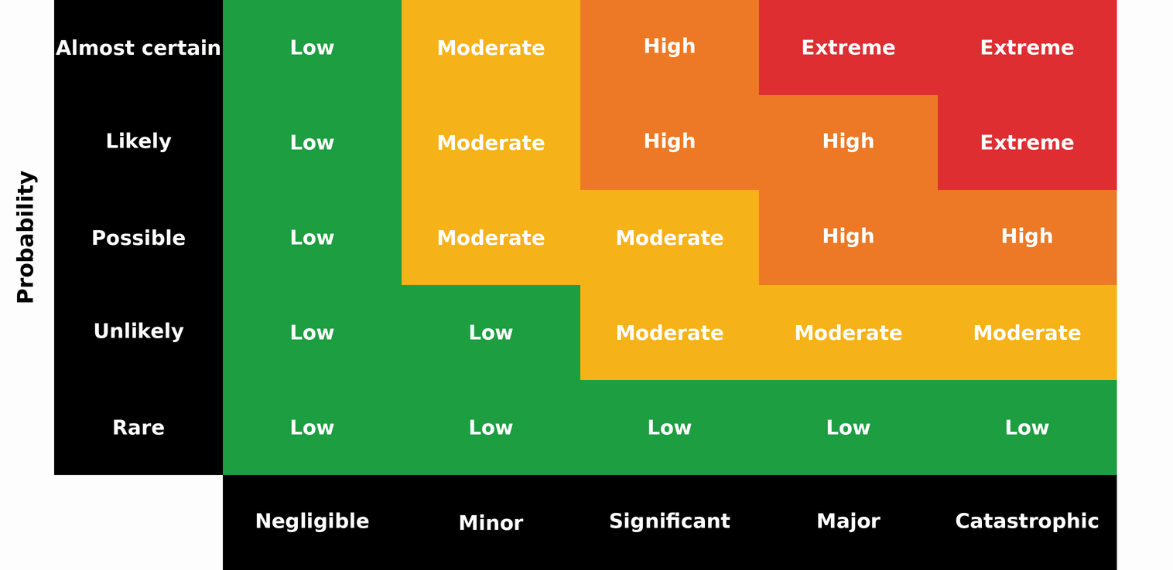
The figure shows the relationship between the probability of occurrence and the severity of impact. Risk levels are classified as low (green), moderate (yellow), high (orange), and extreme (red), according to the combination of both factors.

Table 1. Representative example of a table. Must be placed after its first mention in the text.
Title 1 | Title 2 | Title 3* | Title 4*
Name | Value | Value | Value
Name | Value | Value | Value
Name | Value | Value | Value
Name | Value | Value | Value
Name | Value | Value | Value
Name | Value | Value | Value
Name | Value | Value | Value
Name | Value | Value | Value
Name | Value | Value | Value
Name | Value | Value | Value
Name | Value | Value | Value
*Clarifications on relevant aspects of the information presented may be included.

Table 2. Representative example of a table. Authors may modify the table type. Must be placed after its first mention in the text.
Title 1 | Title 2 | Title 3*
Name | Value | Value
Name | Value | Value
Name | Value | Value
Name | Value | Value
Name | Value | Value
*Clarifications on relevant aspects of the information presented may be included.

Figure X. Altered clinical parameters in COVID-19 patients treated in Internal Medicine (n = 150). Must be placed after its first mention in the text.
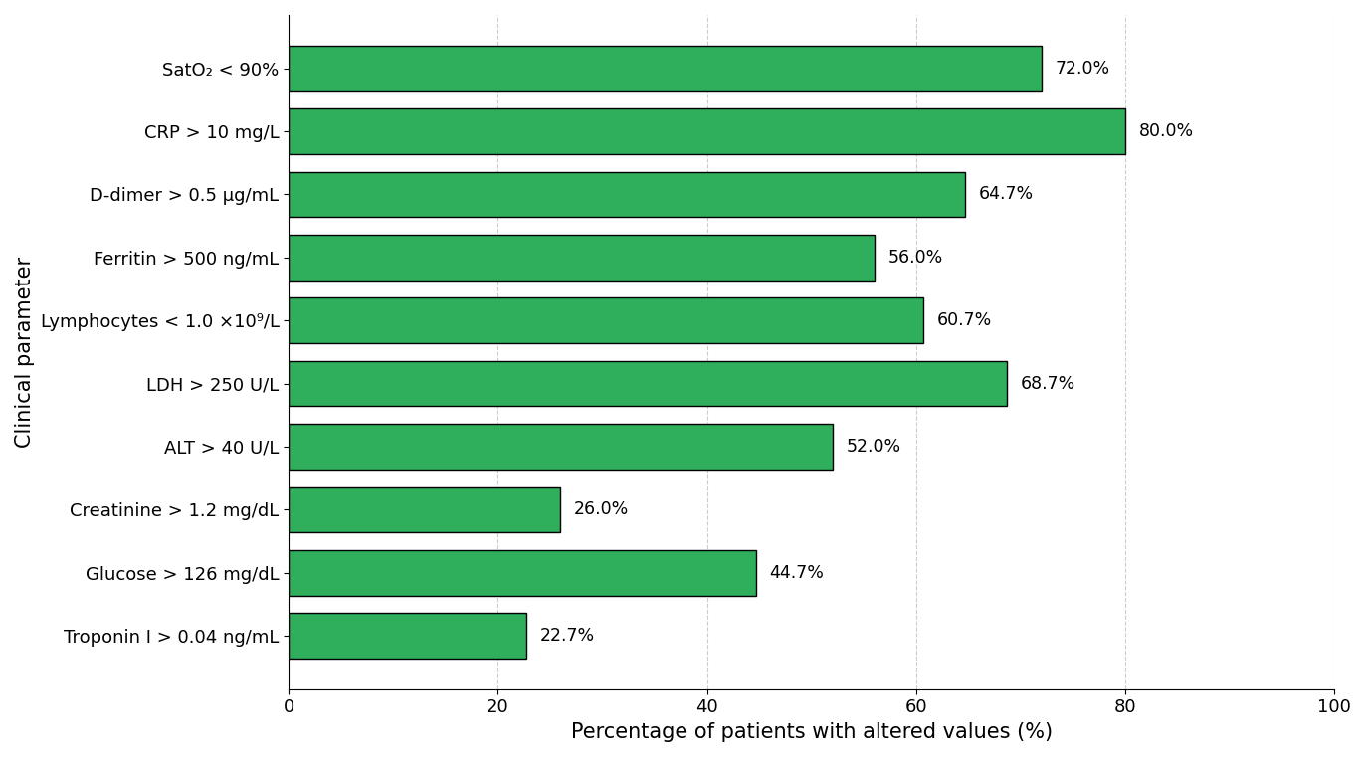

Supplementary material (if applicable)
If there is supplementary material, please indicate what it consists of (e.g., tables, instruments, graphs).

Acknowledgments (if applicable)
Include this section only if applicable. It may be used to acknowledge the collaboration of individuals, institutions, or groups that contributed to the study without meeting authorship criteria.

Data Availability Statement
All manuscripts published in the Revista Especialidad Médica must include a data availability statement. In this section, authors must indicate where the data supporting the reported results can be accessed, including, where applicable, the link to the public repository in which the datasets generated or analyzed during the study are deposited.

Examples:
Data available upon request: The data supporting the results of this study are available upon reasonable request to the corresponding author, subject to applicable ethical and confidentiality considerations.
Data available in repository: The data supporting the results of this study are available in [repository name], at [link or identifier].
Not applicable: Data availability is not applicable to this manuscript, as no datasets were generated or analyzed.

AI Use Statement (if applicable)

If generative artificial intelligence tools were used to support literature synthesis, style review, or any other phase of manuscript preparation, briefly disclose this, specifying the tool used and its purpose. The authors assume full responsibility for the final content. Example:

[Tool name] was used as a support tool for literature synthesis and style review. The author assumes full responsibility for the content.

Author contributions
Briefly and precisely describe the role of each author in the preparation of the manuscript, in accordance with the international CRediT taxonomy (Contributor Roles Taxonomy). Each author must be explicitly associated with one or more contributions and must have reviewed and approved the final version of the manuscript. Submission of the manuscript implies acceptance of individual responsibility for the contributions declared.

Example:
XX XX (Use initials of first and last names only): conceptualization, methodology, writing – original draft; XX XX (Use initials of first and last names only): data curation, formal analysis, validation; XX XX (Use initials of first and last names only): interpretation, supervision, writing – review and editing.
The roles recognized by the CRediT taxonomy include: conceptualization, data curation, formal analysis, funding acquisition, investigation, methodology, project administration, resources, software, supervision, validation, visualization, writing – original draft, and writing – review and editing.

Funding
Indicate the funding sources that supported the study, including institutional projects, public funds, international agencies, non-governmental organizations, or private sponsorship, if applicable.
If no external funding was received, write the following:
This research received no external funding.

Conflicts of interest
Indicate any potential conflicts of interest; if none apply, please state the following:
The authors declare no conflicts of interest.

References (minimum 15; maximum 25)
The purpose of this section is to present a list of up-to-date, relevant, and international sources that scientifically support the content of the manuscript. This is one of the sections with the highest number of errors, so it is recommended to carefully check the accuracy of each reference.

All citations must follow Vancouver style with superscript and be verified before submitting the manuscript, regardless of the reference manager used. DOIs must be functional.

Example for journal articles
Rouleau K, Bourget M, Chege P, Couturier F, Godoy-Ruiz P, Grand’Maison P, et al. Strengthening Primary Care Through Family Medicine Around the World: Collaborating Toward Promising Practices. Fam Med. 2018;50(6):426-436. DOI: 10.22454/FamMed.2018.210965.

Example for web pages
World Health Organization. Life expectancy at birth 2000–2015 [Internet]. [cited 2016 Nov 22]. Available from: https://gamapserver.who.int/gho/interactive_charts/mbd/life_expectancy/atlas.html

Example for complete book
Bell J. Doing your research project. 5th ed. Maidenhead: Open University Press; 2005.

Example for book chapter
Franklin AW. Management of the problem. In: Smith SM, editor. The maltreatment of children. Lancaster: MTP; 2002. p. 83-95.

