Brief Communication
Article Title

Article Title (Spanish)

First name(s) Last name-Last name,¹ First name(s) Last name-Last name,² First name(s) Last name-Last name³*…

¹ Write the author’s complete institutional affiliation, including the area, unit or department, institution, city, and country. Do not use acronyms or abbreviations. ORCID: XXXX-XXXX-XXXX-XXXX. Email: xxxxxxxxxx
² Write the author’s complete institutional affiliation, including the area, unit or department, institution, city, and country. Do not use acronyms or abbreviations. ORCID: XXXX-XXXX-XXXX-XXXX. Email: xxxxxxxxxx
³ Write the author’s complete institutional affiliation, including the area, unit or department, institution, city, and country. Do not use acronyms or abbreviations. ORCID: XXXX-XXXX-XXXX-XXXX. Email: xxxxxxxxxx

*Corresponding author: First name(s) Last name-Last name. Email: xxxxxxxxxx

General Instructions

Before preparing your manuscript, please read this guide carefully.

Contributions must be submitted in Word format (.docx) using this template, which defines the font (Garamond), font size, margins, and line spacing. Manuscripts submitted in PDF or any format other than those specified will not be accepted.

Compliance with this template is a technical requirement for initiating the editorial process. Manuscripts that do not conform to these guidelines may be returned to the authors before editorial evaluation.

This section is intended for reporting pilot studies, preliminary findings, or methodological innovations that provide relevant information for the advancement of scientific knowledge. Manuscripts must present results clearly, concisely, and with sound justification.
The suggested length is 1500 words, not including abstract, keywords, references, or graphic resources. Up to 3 graphic resources (infographics, illustrations, diagrams, or tables) should be included, original, self-explanatory, and submitted in editable format. Images taken from the internet or previously published material will not be accepted. It is recommended to include between 10 and 20 references, with at least 70% published in the last five years, from reliable databases (PubMed, Medline, Scopus, Cochrane, among others). All citations must have a DOI and follow the Vancouver format with superscript.¹

All authors must review and approve the final version of the manuscript prior to submission. Manuscripts containing spelling, grammatical, or structural errors may be returned during the initial editorial review, before being sent for peer review.

Once you have read and understood these guidelines, please delete this section before completing the template.

Abstract
Citation: For journal use only.
Received: XXXXXX
Revised: XXXXXX
Accepted: XXXXXX
Published: XXXXXX

This is an Open Access article under the CC BY-NC-ND license (https://creativecommons.org/licenses/by-nc-nd/4.0).
The suggested length of the abstract is 250 words maximum. It should provide a clear synthesis of the article's purpose, the approach taken, and the central ideas developed, without listing sections or following a rigid structure. It should allow the reader to immediately understand the topic addressed, its relevance, and the main position or argument of the text.
The abstract must accurately reflect the content of the manuscript and its specific contribution. For novice authors, it is recommended that the English version be reviewed by someone with academic command of the language, preferably with experience in scientific writing.

Keywords: include three to six keywords, separated by semicolons; all keywords begin with a capital letter (except acronyms) and must be
validated in the MeSH thesaurus (Medical Subject Headings), available at: https://www.ncbi.nlm.nih.gov/mesh

Abstract (Spanish)

The Spanish abstract must contain the same information as the English abstract.

Keywords (Spanish): provide the keywords in Spanish, separated by commas and written in lowercase, except for proper nouns or acronyms. All must be validated in the MeSH thesaurus (Medical Subject Headings), available at: https://www.ncbi.nlm.nih.gov/mesh

Brief communications may be presented in a free format according to the needs of the text; they may also follow the structure below.

Introduction
The introduction should briefly present the scientific context of the topic addressed, highlighting the relevance of the problem or research area. It should also point out the limitations of existing knowledge or currently used methods, which justifies carrying out the pilot study, the reporting of the preliminary finding, or the proposal of a methodological innovation. This section should conclude with a clear statement of the work's objective.

Methods
This section should clearly and sufficiently describe the methodological approach used.
For pilot or exploratory studies, the study design, the population or sample analyzed, the selection criteria, the procedures performed, the main variables evaluated, and the type of analysis performed must be specified.
For methodological innovations, the conceptual basis of the proposed method, its main components, the procedures for its implementation, and the context in which it can be applied must be explained.
When applicable, the ethical considerations of the study should also be mentioned, including approval by an ethics committee and the obtaining of informed consent.

Results
Present the main findings obtained in the study or the results of the initial application of the proposed method or tool. The results should be presented clearly, objectively, and concisely, and without interpretation. The results must correspond directly to the study objective and follow the same sequence described in the Methods.
When relevant, results may be supported by tables or figures, always respecting the maximum limit of two graphic resources. Each table, figure, or graph must be inserted immediately after its first mention in the text and be contained within the body of the manuscript. The use of graphic resources should be justified, preferably for data involving more than four variables.
Tables must be editable, while figures and graphs must have a minimum resolution of 300 DPI and dimensions no smaller than 20 × 20 cm. All must include a title and, where applicable, a figure or table caption; examples are provided below.

Figure 1. Risk assessment matrix. Must be placed after its first mention in the text.
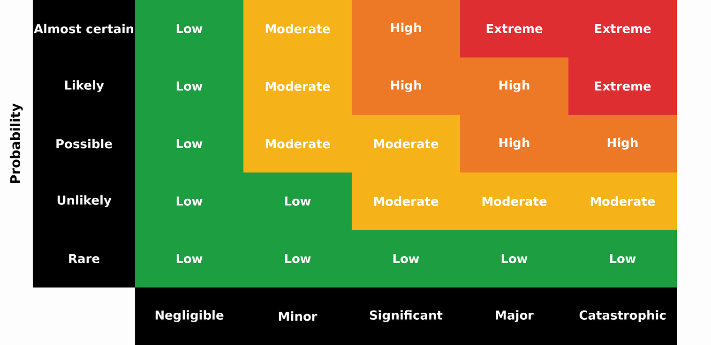
The figure shows the relationship between the probability of occurrence and the severity of impact. Risk levels are classified as low (green), moderate (yellow), high (orange), and extreme (red), according to the combination of both factors.

Table 1. Representative example of a table. Must be placed after its first mention in the text.
Title 1 | Title 2 | Title 3* | Title 4*
Name | Value | Value | Value
Name | Value | Value | Value
Name | Value | Value | Value
Name | Value | Value | Value
Name | Value | Value | Value
Name | Value | Value | Value
Name | Value | Value | Value
Name | Value | Value | Value
Name | Value | Value | Value
Name | Value | Value | Value
Name | Value | Value | Value
*Clarifications on relevant aspects of the information presented may be included.

Table 2. Representative example of a table. Authors may modify the table type. Must be placed after its first mention in the text.
Title 1 | Title 2 | Title 3*
Name | Value | Value
Name | Value | Value
Name | Value | Value
Name | Value | Value
Name | Value | Value
*Clarifications on relevant aspects of the information presented may be included.

Figure X. Altered clinical parameters in COVID-19 patients treated in Internal Medicine (n = 150). Must be placed after its first mention in the text.
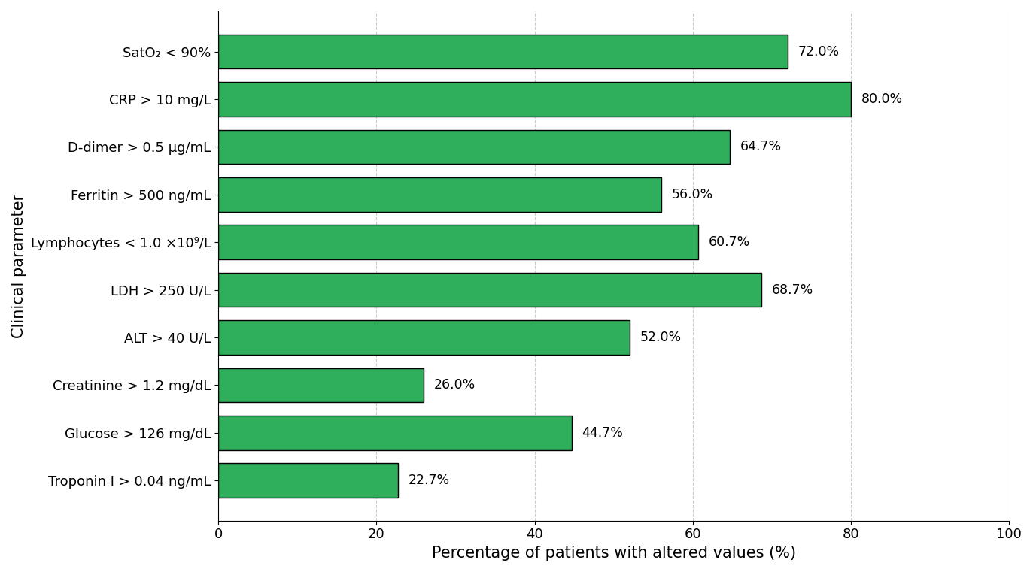

Discussion
The discussion should interpret the results obtained or analyze the usefulness and relevance of the proposed methodological innovation.
In this section, the findings may be compared with previous studies or existing methods, the work's main contributions may be highlighted, and its possible implications for research or professional practice may be discussed. It is also important to note the limitations of the study or method presented, as well as possible future lines of research.

Conclusion
The conclusion should synthesize the main contribution of the study, the preliminary finding, or the methodological innovation presented. This section should briefly highlight the work's potential relevance and its possible contribution to the development of the field of study.

Supplementary material (if applicable)
If there is supplementary material, please indicate what it consists of (e.g., tables, instruments, graphs).

Acknowledgments (if applicable)
Include this section only if applicable. It may be used to acknowledge the collaboration of individuals, institutions, or groups that contributed to the study without meeting authorship criteria.

Data Availability Statement
All manuscripts published in the Revista Especialidad Médica must include a data availability statement. In this section, authors must indicate where the data supporting the reported results can be accessed, including, where applicable, the link to the public repository in which the datasets generated or analyzed during the study are deposited.

Examples:
Data available upon request: The data supporting the results of this study are available upon reasonable request to the corresponding author, subject to applicable ethical and confidentiality considerations.
Data available in repository: The data supporting the results of this study are available in [repository name], at [link or identifier].
Not applicable: Data availability is not applicable to this manuscript, as no datasets were generated or analyzed.

AI Use Statement (if applicable)

If generative artificial intelligence tools were used to support literature synthesis, style review, or any other phase of manuscript preparation, briefly disclose this, specifying the tool used and its purpose. The authors assume full responsibility for the final content. Example:

[Tool name] was used as a support tool for literature synthesis and style review. The author assumes full responsibility for the content.

Author contributions
Briefly and precisely describe the role of each author in the preparation of the manuscript, in accordance with the international CRediT taxonomy (Contributor Roles Taxonomy). Each author must be explicitly associated with one or more contributions and must have reviewed and approved the final version of the manuscript. Submission of the manuscript implies acceptance of individual responsibility for the contributions declared.

Example:
XX XX (Use initials of first and last names only): conceptualization, methodology, writing – original draft; XX XX (Use initials of first and last names only): data curation, formal analysis, validation; XX XX (Use initials of first and last names only): interpretation, supervision, writing – review and editing.
The roles recognized by the CRediT taxonomy include: conceptualization, data curation, formal analysis, funding acquisition, investigation, methodology, project administration, resources, software, supervision, validation, visualization, writing – original draft, and writing – review and editing.

Funding
Indicate the funding sources that supported the study, including institutional projects, public funds, international agencies, non-governmental organizations, or private sponsorship, if applicable.
If no external funding was received, write the following:
This research received no external funding.

Conflicts of interest
Indicate any potential conflicts of interest; if none apply, please state the following:
The authors declare no conflicts of interest.

References (minimum 10; maximum 20)
The purpose of this section is to present a list of up-to-date, relevant, and international sources that scientifically support the content of the manuscript. This is one of the sections with the highest number of errors, so it is recommended to carefully check the accuracy of each reference.

All citations must follow Vancouver style with superscript and be verified before submitting the manuscript, regardless of the reference manager used. DOIs must be functional.

Example for journal articles
Rouleau K, Bourget M, Chege P, Couturier F, Godoy-Ruiz P, Grand’Maison P, et al. Strengthening Primary Care Through Family Medicine Around the World: Collaborating Toward Promising Practices. Fam Med. 2018;50(6):426-436. DOI: 10.22454/FamMed.2018.210965.

Example for web pages
World Health Organization. Life expectancy at birth 2000–2015 [Internet]. [cited 2016 Nov 22]. Available from: https://gamapserver.who.int/gho/interactive_charts/mbd/life_expectancy/atlas.html

Example for complete book
Bell J. Doing your research project. 5th ed. Maidenhead: Open University Press; 2005.

Example for book chapter
Franklin AW. Management of the problem. In: Smith SM, editor. The maltreatment of children. Lancaster: MTP; 2002. p. 83-95.

