Original Article
Article Title

Article Title (Spanish)

First name(s) Last name-Last name,¹ First name(s) Last name-Last name,² First name(s) Last name-Last name³*…

¹ Write the author’s complete institutional affiliation, including the area, unit or department, institution, city, and country. Do not use acronyms or abbreviations. ORCID: XXXX-XXXX-XXXX-XXXX. Email: xxxxxxxxxx
² Write the author’s complete institutional affiliation, including the area, unit or department, institution, city, and country. Do not use acronyms or abbreviations. ORCID: XXXX-XXXX-XXXX-XXXX. Email: xxxxxxxxxx
³ Write the author’s complete institutional affiliation, including the area, unit or department, institution, city, and country. Do not use acronyms or abbreviations. ORCID: XXXX-XXXX-XXXX-XXXX. Email: xxxxxxxxxx

*Corresponding author: First name(s) Last name-Last name. Email: xxxxxxxxxx

General Instructions

Before preparing your manuscript, please read this guide carefully.

Contributions must be submitted in Word format (.docx) using this template, which defines the font (Garamond), font size, margins, and line spacing. Manuscripts submitted in PDF or any format other than those specified will not be accepted.

Compliance with this template is a technical requirement for initiating the editorial process. Manuscripts that do not conform to these guidelines may be returned to the authors before editorial evaluation.

This section publishes previously unpublished results of original quantitative or qualitative research related to the different medical specialties and related fields. Manuscripts should provide relevant scientific evidence, present a clearly described methodology, and contribute to the advancement of knowledge, clinical practice, or health care.

Suggested length: 3,000 words; maximum length: 4,500 words, excluding the abstract, keywords, references, and graphical materials. Manuscripts may include up to 5 graphical materials (infographics, illustrations, diagrams, or tables), which must be original, self-explanatory, and submitted in an editable format. Images obtained from the Internet or previously published materials will not be accepted. Authors are encouraged to include 24 to 40 references, at least 70% of which should have been published within the last five years and retrieved from reliable databases (PubMed, MEDLINE, Scopus, Cochrane, among others). All cited references must include a DOI and follow Vancouver style, with citations presented as superscript numbers.¹

The use of international reporting guidelines appropriate to the study design is recommended, as they help improve the structure, transparency, and quality of the manuscript. Among the most widely used are:

- STROBE – observational studies
- CONSORT – randomized clinical trials
- PRISMA – systematic reviews and meta-analyses
- MOOSE – meta-analyses of observational studies
- SRQR / COREQ – qualitative studies

It is suggested that the corresponding checklist be attached as supplementary material. To consult these guidelines, visit: https://www.equator-network.org

All authors must review and approve the final version of the manuscript prior to submission. Manuscripts containing spelling, grammatical, or structural errors may be returned during the initial editorial review, before being sent for peer review.

Once you have read and understood these guidelines, please delete this section before completing the template.

Abstract
The suggested length for this section is up to 250 words.
Objective: concisely state the main purpose of the study. Methods: describe the essential aspects of the methodology used (study type, sample size calculation and sampling method, selection criteria, instruments used, statistical analysis, and level of significance, if applicable). Results: present the most relevant findings in relation to the stated objective and methods. Conclusion: state the main conclusion drawn from the results obtained.

Citation: For journal use only.
Received: XXXXXX
Revised: XXXXXX
Accepted: XXXXXX
Published: XXXXXX

This is an Open Access article under the CC BY-NC-ND license (https://creativecommons.org/licenses/by-nc-nd/4.0).
Keywords: include three to six keywords, separated by semicolons; all keywords begin with a capital letter (except acronyms) and must be validated in the MeSH thesaurus (Medical Subject Headings), available at: https://www.ncbi.nlm.nih.gov/mesh

Abstract (Spanish)

The Spanish abstract must contain the same information as the English abstract, with a parallel structure (Objetivo, Métodos, Resultados, Conclusión).

Keywords (Spanish): provide the keywords in Spanish, separated by commas and written in lowercase, except for proper nouns or acronyms. All must be validated in the MeSH thesaurus (Medical Subject Headings), available at: https://www.ncbi.nlm.nih.gov/mesh

Introduction
The introduction must clearly state the relevance of the problem, the knowledge gap identified in the literature, and the study's contribution to addressing it. It must include at least 12 references, of which 70% should correspond to the last five years, cited in Vancouver style with superscript.¹ The use of reference managers such as Zotero, EndNote, or Mendeley is recommended, always verifying the accuracy of each reference. Conclude with the study objective.

Material and Methods
Describe clearly and concisely how the study was conducted, so that it can be reproduced by other researchers. Write this section in the past tense. Include the type of study, the population, the place and period in which it was conducted, the sample size and type, and the inclusion, exclusion, and elimination criteria. State whether informed consent was obtained and specify whether any reporting guideline was used (e.g., STROBE, SRQR, CONSORT, among others).
Describe how the data were collected and cite the clinical guidelines used to define parameters. Specify the instruments used (if applicable), their cut-off points, validity, and reliability. If the instruments have not been validated in the target population, justify their use with a conceptual basis and minimal statistical evidence.
Indicate the type of statistical analysis used (descriptive, inferential, or both), the tests applied, the level of significance, and the software used.
Include the name of the ethics committee that approved the protocol, along with the approval number and date.

Results
Present the study findings clearly and objectively, without interpretation. The results must correspond directly to the study objective and follow the same sequence described in the Methods.

Always use absolute numbers accompanied by their respective percentages.

Present the main results in a structured way, without repeating information between the text and graphic resources. Each table, figure, or graph must be inserted immediately after its first mention in the text and be contained within the body of the manuscript. The use of graphic resources should be justified, preferably for data involving more than four variables.
A maximum of five graphic resources in total is allowed (tables, figures, or graphs). Tables must be editable, while figures and graphs must have a minimum resolution of 300 DPI and dimensions no smaller than 20 × 20 cm. All must include a title and, where applicable, a figure or table caption; examples are provided below.

Figure 1 shows the relationship between the probability of occurrence and the severity of impact. Risk levels are classified as low (green), moderate (yellow), high (orange), and extreme (red), according to the combination of both factors.

Figure 1. Risk assessment matrix. Must be placed after its first mention in the text.

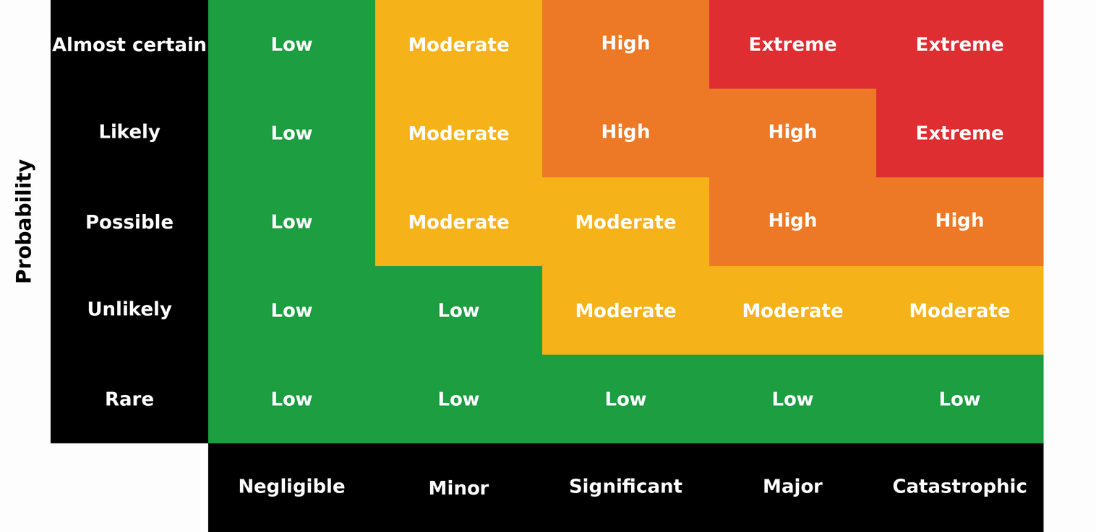

Table 1. Representative example of a table. Must be placed after its first mention in the text.
Title 1 | Title 2 | Title 3* | Title 4*
Name | Value | Value | Value
Name | Value | Value | Value
Name | Value | Value | Value
Name | Value | Value | Value
Name | Value | Value | Value
Name | Value | Value | Value
Name | Value | Value | Value
Name | Value | Value | Value
Name | Value | Value | Value
Name | Value | Value | Value
Name | Value | Value | Value
*Clarifications on relevant aspects of the information presented may be included.

Table 2. Representative example of a table. Authors may modify the table type. Must be placed after its first mention in the text.
Title 1 | Title 2 | Title 3*
Name | Value | Value
Name | Value | Value
Name | Value | Value
Name | Value | Value
Name | Value | Value
*Clarifications on relevant aspects of the information presented may be included.

Figure X. Altered clinical parameters in COVID-19 patients treated in Internal Medicine (n = 150). Must be placed after its first mention in the text.
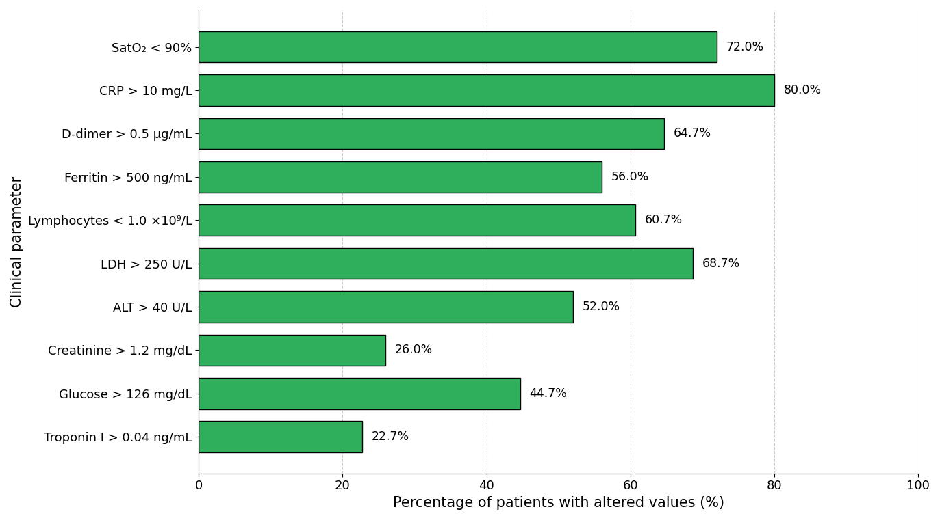

Discussion
The discussion should focus on interpreting the study findings in relation to the current scientific literature. Avoid repeating results or including variables not directly related to the study objective. Use a minimum of 12 reliable and up-to-date references, following the criteria established in the Introduction, and cite them in Vancouver style with superscript.
The main purpose of this section is to compare the results with existing evidence, identifying agreements or discrepancies with previous studies and analyzing their possible causes. Every statement must be supported by verifiable sources; repetitions, speculation, and unsupported generalizations are not allowed.
Transparently identify the strengths and limitations of the research, without minimizing methodological weaknesses.

Conclusions
Write a conclusion of approximately 100 words, related to the study objectives. Avoid general summaries or statements not supported by the findings. Clearly state the study's main contribution and its clinical, academic, or institutional applicability.

Supplementary material (if applicable)
If there is supplementary material, please indicate what it consists of (e.g., tables, instruments, graphs).

Acknowledgments (if applicable)
Include this section only if applicable. It may be used to acknowledge the collaboration of individuals, institutions, or groups that contributed to the study without meeting authorship criteria.

Data Availability Statement
All manuscripts published in the Revista Especialidad Médica must include a data availability statement. In this section, authors must indicate where the data supporting the reported results can be accessed, including, where applicable, the link to the public repository in which the datasets generated or analyzed during the study are deposited.

Examples:
Data available upon request: The data supporting the results of this study are available upon reasonable request to the corresponding author, subject to applicable ethical and confidentiality considerations.
Data available in repository: The data supporting the results of this study are available in [repository name], at [link or identifier].
Not applicable: Data availability is not applicable to this manuscript, as no datasets were generated or analyzed.

AI Use Statement (if applicable)

If generative artificial intelligence tools were used to support literature synthesis, style review, or any other phase of manuscript preparation, briefly disclose this, specifying the tool used and its purpose. The authors assume full responsibility for the final content. Example:

[Tool name] was used as a support tool for literature synthesis and style review. The author assumes full responsibility for the content.

Author contributions
Briefly and precisely describe the role of each author in the preparation of the manuscript, in accordance with the international CRediT taxonomy (Contributor Roles Taxonomy). Each author must be explicitly associated with one or more contributions and must have reviewed and approved the final version of the manuscript. Submission of the manuscript implies acceptance of individual responsibility for the contributions declared.

Example:
XX XX (Use initials of first and last names only): conceptualization, methodology, writing – original draft; XX XX (Use initials of first and last names only): data curation, formal analysis, validation; XX XX (Use initials of first and last names only): interpretation, supervision, writing – review and editing.
The roles recognized by the CRediT taxonomy include: conceptualization, data curation, formal analysis, funding acquisition, investigation, methodology, project administration, resources, software, supervision, validation, visualization, writing – original draft, and writing – review and editing.

Funding
Indicate the funding sources that supported the study, including institutional projects, public funds, international agencies, non-governmental organizations, or private sponsorship, if applicable.
If no external funding was received, write the following:
This research received no external funding.

Conflicts of interest
Indicate any potential conflicts of interest; if none apply, please state the following:
The authors declare no conflicts of interest.

References (minimum 24; maximum 40)
The purpose of this section is to present a list of up-to-date, relevant, and international sources that scientifically support the content of the manuscript. This is one of the sections with the highest number of errors, so it is recommended to carefully check the accuracy of each reference.

All citations must follow Vancouver style with superscript and be verified before submitting the manuscript, regardless of the reference manager used. DOIs must be functional.

Example for journal articles
Rouleau K, Bourget M, Chege P, Couturier F, Godoy-Ruiz P, Grand’Maison P, et al. Strengthening Primary Care Through Family Medicine Around the World: Collaborating Toward Promising Practices. Fam Med. 2018;50(6):426-436. DOI: 10.22454/FamMed.2018.210965.

Example for web pages
World Health Organization. Life expectancy at birth 2000–2015 [Internet]. [cited 2016 Nov 22]. Available from: https://gamapserver.who.int/gho/interactive_charts/mbd/life_expectancy/atlas.html

Example for complete book
Bell J. Doing your research project. 5th ed. Maidenhead: Open University Press; 2005.

Example for book chapter
Franklin AW. Management of the problem. In: Smith SM, editor. The maltreatment of children. Lancaster: MTP; 2002. p. 83-95.

